使用步骤

新springcloud-eureka--zuul-gateway-9527工程

pom文件
<project xmlns="http://maven.apache.org/POM/4.0.0" xmlns:xsi="http://www.w3.org/2001/XMLSchema-instance"
xsi:schemaLocation="http://maven.apache.org/POM/4.0.0 http://maven.apache.org/xsd/maven-4.0.0.xsd">
<modelVersion>4.0.0</modelVersion>
<parent>
<groupId>org.springframework.boot</groupId>
<artifactId>spring-boot-starter-parent</artifactId>
<version>1.5.17.RELEASE</version>
</parent>

<groupId>com.sxt</groupId>
<artifactId>springcloud-eureka--zuul-gateway-9527</artifactId>
<version>0.0.1-SNAPSHOT</version>

<properties>
<java.version>1.8</java.version>
</properties>

<dependencyManagement>
<dependencies>
<dependency>
<groupId>org.springframework.cloud</groupId>
<artifactId>spring-cloud-dependencies</artifactId>
<version> Camden.SR6</version>
<type>pom</type>
<scope>import</scope>
</dependency>
</dependencies>
</dependencyManagement>

<dependencies>
<dependency>
<groupId>org.springframework.boot</groupId>
<artifactId>spring-boot-starter-web</artifactId>
</dependency>
<dependency>
<groupId>org.springframework.cloud</groupId>
<artifactId>spring-cloud-starter-eureka</artifactId>
</dependency>
<!--zuul路由网关 -->
<dependency>
<groupId>org.springframework.cloud</groupId>
<artifactId>spring-cloud-starter-zuul</artifactId>
</dependency>
</dependencies>
</project>

全局配置文件
spring.application.name=gateway-9527
server.port=9527

#设置服务注册中心地址，指向另一个注册中心
eureka.client.serviceUrl.defaultZone=http://eureka1:8761/eureka/,http://eureka2:8761/eureka/

#/apiuser/开头的url请求，将转发到eureka-provider这个微服务上
zuul.routes.apiuser.path=/apiuser/**
zuul.routes.apiuser.serviceId=eureka-provider

启动类
@SpringBootApplication
@EnableEurekaClient
@EnableZuulProxy
public class Zuul_9527_StartSpringCloudApp {

public static void main(String[] args) {
SpringApplication.run(Zuul_9527_StartSpringCloudApp.class, args);
}
}

测试
1、开启springcloud-eureka-hystrix-provider-8777
2、开启springcloud-eureka--zuul-gateway-9527
3、不使用路由规则：http://127.0.0.1:9527/eureka-provider/user/1

其中http://127.0.0.1:9527，是Zuul服务实例的访问地址；而eureka-provider是springcloud-eureka-hystrix-provider服务的service ID
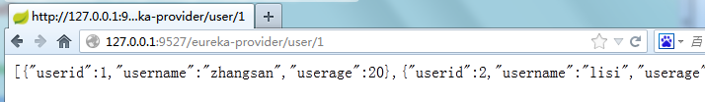

4、使用路由规则：http://127.0.0.1:9527/apiuser/user/1
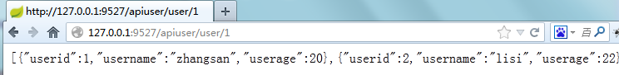
问题：
现在不论是否使用路由都可以正常访问，如果需要隐藏真实的服务名称进行访问（只能使用代理路由进行访问）如何实现?

路由访问映射规则

实现隐藏原真实服务名

修改全局配置文件
spring.application.name=gateway-9527
server.port=9527

#设置服务注册中心地址，指向另一个注册中心
eureka.client.serviceUrl.defaultZone=http://eureka1:8761/eureka/,http://eureka2:8761/eureka/

#访问路径可以显示IP地址
eureka.instance.instance-id=springcloud-eureka--zuul-gateway-9527
#访问路径可以显示IP地址
eureka.instance.prefer-ip-address=true

#info页面展现配置
info.app.name=springcloud-eureka--zuul-gateway-9527
info.company.name=www.sxt.cn
info.build.artifactId=$project.artifactId$
info.build.version=$project.version$

#/apiuser/开头的url请求，将转发到eureka-provider这个微服务上
zuul.routes.apiuser.path=/apiuser/**
zuul.routes.apiuser.serviceId=eureka-provider
#忽略的服务,多个可以用*
#zuul.ignored-services=eureka-provider
zuul.ignored-services=*

测试
使用路由规则：http://127.0.0.1:9527/apiuser/user/1
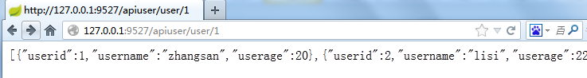

不使用路由规则：http://127.0.0.1:9527/eureka-provider/user/1
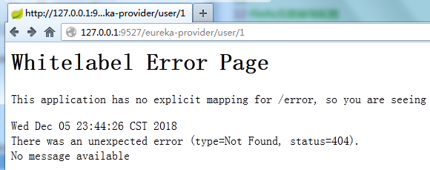

设置统一公共前缀

修改全局配置文件
spring.application.name=gateway-9527
server.port=9527

#设置服务注册中心地址，指向另一个注册中心
eureka.client.serviceUrl.defaultZone=http://eureka1:8761/eureka/,http://eureka2:8761/eureka/

#访问路径可以显示IP地址
eureka.instance.instance-id=springcloud-eureka--zuul-gateway-9527
#访问路径可以显示IP地址
eureka.instance.prefer-ip-address=true

#info页面展现配置
info.app.name=springcloud-eureka--zuul-gateway-9527
info.company.name=www.sxt.cn
info.build.artifactId=$project.artifactId$
info.build.version=$project.version$

#/apiuser/开头的url请求，将转发到eureka-provider这个微服务上
zuul.prefix=/sxt
zuul.routes.apiuser.path=/apiuser/**
zuul.routes.apiuser.serviceId=eureka-provider
#忽略的服务,多个可以用*
#zuul.ignored-services=eureka-provider
zuul.ignored-services=*

测试
http://127.0.0.1:9527/sxt/apiuser/user/1
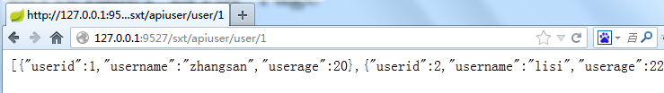

Spring Cloud Zuul实战

重写ZuulFilter
public class AccessFilter extends ZuulFilter {

// 要干的活：屏蔽骂脏话
@Override
public Object run() {
try {
// 当前请求环境
RequestContext currentContext = RequestContext.getCurrentContext();
HttpServletRequest request = currentContext.getRequest();
HttpServletResponse response = currentContext.getResponse();
response.setContentType("text/html;charset=UTF-8");
String zh = "滚,fuck,shit,日,晶";
String str = request.getParameter("str");
System.out.println(str + "------------------------------------");
if (zh.indexOf(str) != -1) {
currentContext.setSendZuulResponse(false);
PrintWriter writer = response.getWriter();
writer.write("禁止骂脏话");
writer.flush();
writer.close();
}
} catch (Exception e) {
e.printStackTrace();
}
return null;
}

@Override
public boolean shouldFilter() {
return true;
}

@Override
public int filterOrder() {
return 0;
}

@Override
public String filterType() {
return "pre";
}
}

配置类
@Configuration
public class ConfigBean {

@Bean
public AccessFilter accessFilter(){
return new AccessFilter();
}
}

测试
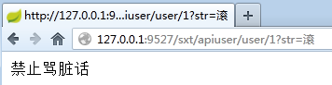

zuul预处理consumer

修改全局配置文件
spring.application.name=gateway-9527
server.port=9527

#设置服务注册中心地址，指向另一个注册中心
eureka.client.serviceUrl.defaultZone=http://eureka1:8761/eureka/,http://eureka2:8761/eureka/

#/**开头的url请求，将转发到eureka-consumer这个微服务上
zuul.routes.apiuser.path=/**
zuul.routes.apiuser.serviceId=eureka-consumer
#忽略的服务,多个可以用*
#zuul.ignored-services=eureka-provider
zuul.ignored-services=*

AccessFilter判空
@Override
public Object run() {
RequestContext currentContext = RequestContext.getCurrentContext();
HttpServletRequest request = currentContext.getRequest();
HttpServletResponse response = currentContext.getResponse();
response.setContentType("text/html;charset=UTF-8");
String zh = "滚,日,shit,fuck,晶,靠";
String str = request.getParameter("str");
if(str==null){
return null;
}
if(zh.indexOf(str)!=-1){
System.out.println(str+"-----------------------------------");
//网关不放行
currentContext.setSendZuulResponse(false);
PrintWriter writer = null;
try {
writer = response.getWriter();
} catch (Exception e) {
e.printStackTrace();
}
writer.write("禁止骂脏话");
writer.flush();
writer.close();
}
return null;
}

